PROJECT REPORT
On

CURIOSITY CAMPUS
Submitted in partial fulfillment of requirements for the award of the degree

Bachelor of Technology
In
Computer Science and Engineering
To
IKG Punjab Technical University, Jalandhar

SUBMITTED BY:
Name: Twinkle Raj
Roll no.: 2237717
Semester: 8th
Batch: 2025
Under the guidance of
Mr. Rajeev Sharma Assistant Professor


DEPARTMENT OF COMPUTER SCIENCE AND ENGINEERING
Chandigarh Engineering College-CGC, Landran Mohali, Punjab - 140307

CERTIFICATE

This is to certify that Ms. Twinkle Raj has partially completed / completed / not completed the Semester Training during the period from July 2024 to Dec 2024 in our Organization / Industry as a Partial Fulfillment of Degree of Bachelor of Technology in Computer Science & Engineering.

(Signature of Project Supervisor)

Date: 13-11-2024

CANDIDATE DECLARATION

I hereby declare that the Project Report entitled ("Curiosity Campus ") is an authentic record of my own work as requirements of 8th semester academic during the period from July 2024 to Dec 2024 for the award of degree of B.Tech. (Computer Science & Engineering, Chandigarh Engineering College- CGC, Landran, Mohali under the guidance of Mr. Rajeev Sharma.

Date: 13-11-2024
(Signature of student) (Twinkle Raj)

(2237717)

Certified that the above statement made by the student is correct to the best of our knowledge and belief.

Signatures Examined by:
1. 2. 3. 4.

Head of Department (Signature and Seal)

ACKNOWLEDGMENT

I take this opportunity to express my sincere gratitude to the Director- Principal Dr. Rajdeep Singh Chandigarh Engineering College, Landran for providing this opportunity to carry out the present work.

I am highly grateful to the Dr. Sukhpreet Kaur HOD CSE, Chandigarh Engineering College, Landran (Mohali). I would like to expresses my gratitude to other faculty members of Computer Science & Engineering department of CEC, Landran for providing academic inputs, guidance & Encouragement throughout the training period. The help rendered by Mr. Rajeev Sharma, Supervisor for Experimentation is greatly acknowledged. I would also like to acknowledge the help of my Project Partner, Amita Rana, who helped me all along the building of this project. Finally, I express my indebtedness to all who have directly or indirectly contributed to the successful completion of my semester training.

ABSTRACT

"Welcome to our online education platform, a dynamic and comprehensive hub designed to cater to diverse learning needs. Our website is a digital ecosystem offering a wide array of educational resources, tools, and interactive content, fostering an inclusive learning environment for students, educators, and lifelong learners. From K-12 curriculum support to higher education materials, professional development resources, and specialized courses, our platform aims to inspire, engage, and empower learners of all ages and backgrounds.
With a user-friendly interface, personalized learning experiences, and innovative teaching methodologies, we strive to revolutionize the way knowledge is accessed and shared in the digital age. Join us on a journey of exploration, discovery, and growth as we embrace the limitless possibilities of education in the 21st century."

Table Of Contents

CONTENT PAGE NO.

Certificate i
Candidate Declaration ii
Acknowledgement iii
Abstract iv
Table of Contents v
List of Figures viii
Chapter 1 : Introduction 1
  - Overview 1
  - Advantages 2
1.3 Introduction of Project 3
  - Aim and Objective of Project 4
  - Purpose 5
  - Scope 6
Chapter 2 : Analysis and System Requirements 8
  - Current System 8
  - Future System 8
  - Software Requirements 8

  - Hardware Requirements 11
Chapter 3 : System Design 13
  - UML Diagram 13
    - Use Case Diagram 13
  - Data Flow Diagram 15
    - Level 1 DFD 15
  - Flow chart. 17
Chapter 4 : Implementation and Testing 18
  - Testing 18
    - Unit Testing 19
    - System Testing 21
  - Test Cases 23
  - Implementation and Challenges 25
Chapter 5 : Snapshots 27
Chapter 6 : Future scope 30
  - Introduction 30
  - Security Software 31
Chapter 7 : Conclusion 32
  - Summary of achievements 32
  - Challenges and Solutions 32
7.3 Benefits 33
Chapter 8 : References 36

List Of Figures

CONTENT PAGE NO.
Figure 3.1.1- Use case Diagram…………..……………………………………………14
Figure 3.2- Level 1 DFD…………………………………………………………..….. 16
Figure 3.3- Flowchart…………………………………………………………………..17
Figure 5.1- Home Page………………………………………………..………………..27
Figure 5.2- About Page…………………………………………………………………27
Figure 5.3- Courses Page……………………………………………………………….28
Figure 5.4- Categories Page…………………………………………………………….28
Figure 5.5- Login Page…………………………………………………………………29
Figure 5.6- Contact Page……………………………………………………………….29

Chapter 1 : Introduction

Overview of Work

The world is full of technology driven factors in our day to day life. We have so many technologies, throughout the world computer technologies are growing simultaneously. They are used to perform various tasks which cannot be performed by humans. In fact they are ruling the human lives because they have a potential to do the tasks which cannot be done by humans. The interaction between human and computer can be done with output device like mouse. The mouse is a device used for interacting with a GUI which includes pointing, scrolling and moving etc. The hardware mouse in computers and touchpads in laptops will require a huge amount of time to perform complex tasks, incase we are carrying hardware mouse wherever we go it would be damaged sometimes.

After decades the technology has made the mouse functionality from wired into the wireless to improve the functionality and for the easy movements in hassle free manner. As the technologies started growing there came the speech recognition technique. This recognition is mainly used for the voice recognition purpose for searching something with the help of their voice and for translation purposes but it can take time for recognition to perform mouse functions. Later the human computer interaction evolved with the eye tracking techniques for controlling the cursor of the mouse. The major drawback of this technique is that some may wear contact lens or some may have long eyelashes so it may take some time to capture their eye movement.

Different types of attempts taken by many developers for developing the models for human gesture recognition. Those models require expensive gloves and sensors for capturing and color cap for marking the positions of the fingertips. The technologies are still emerging, one of the vast technologies artificial intelligence is playing a major role in every sector. Artificial intelligence makes human life fast and comfortable. To overcome the problems faced in the existing approaches we are going for the latest algorithms and tools in artificial intelligence. Hand gesture controlled virtual mouse using artificial intelligence is a technology that allows users
1

to control the movement of their computer mouse using hand gestures, without the advent of a physical mouse.

This technology uses a camera vision based approach to track the movements of the user’s hand and to perform mouse functions on the computer screen. The system works by capturing video input from a camera pointed at the user’s hand. The computer vision algorithms then analyze the video feed to identify the user’s hand and track its movement. This information is given to machine learning models which have been trained to recognize specific hand gestures, such as pointing or swiping, and translate them into corresponding mouse movements. This latest super cool technology has various advantages, including its potential to improve accessibility for people and its ability to provide a more natural and intuitive user experience. It can also be useful in situations where a physical mouse or touchpad is not available or practical. The use of hand gestures as a control mechanism eliminates the need for a physical mouse and provides a more intuitive and natural way of interaction with computers. This technology has numerous applications in areas such as gaming, virtual reality and accessibility quite easy for people.

A mouse, in computing terms is a pointing device that detects two-dimensional
movements relative to a surface. This movement is converted into the movement of a pointer on a display that allows to control the Graphical User Interface (GUI) on a computer platform. There are a lot of different types of mouse that have already existed in the modern days technology, there's the mechanical mouse that
determines the movements by a hard rubber ball that rolls around as the mouse is moved.

Years later, the optical mouse was introduced that replace the hard rubber ball to a LED sensor to detects table top movement and then sends off the information to the computer for processing. On the year 2004, the laser mouse was then introduced to improve the accuracy movement with the slightest hand movement, it overcome the limitations of the optical mouse which is the difficulties to track high-gloss surfaces. However, no matter how accurate can it be, there are still limitations exist

within the mouse itself in both physical and technical terms. For example, a computer mouse is a consumable hardware device as it requires replacement in the long run, either the mouse buttons were degraded that causes inappropriate clicks, or the whole mouse was no longer detected by the computer itself.

Despite the limitations, the computer technology still continues to grow, so does the importance of the human computer interactions. Ever since the introduction of a
mobile device that can be interact with touch screen technology, the world is starting to demand the same technology to be applied on every technological
devices, this includes the desktop system. However, even though the touch screen technology for the desktop system is already exist, the price can be very steep.

Therefore, a virtual human computer interaction device that replaces the physical mouse or keyboard by using a webcam or any other image capturing devices can be an alternative way for the touch screen.
This device which is the webcam will be constantly utilized by a software that
monitors the gestures given by the user in order to process it and translate to motion of a pointes, as similar to a physical mouse.

Gesture Controlled Virtual Mouse makes human-computer interaction simple by m aking use of Hand Gestures and Voice Commands. The computer requires almost n o direct contact. All i/o operations can be virtually controlled by using static and dy namic hand gestures along with a voice assistant.

This project makes use of state-of-art Machine Learning and Computer Vision algor ithms to recognize hand gestures and voice commands, which works smoothly with out any additional hardware requirements. It leverages models such as CNN imple mented by Media Pipe running on top of pybind11. It consists of two modules: One which works direct on hands by making use of Media Pipe Hand detection, and the

other which makes use of Gloves of any uniform color. Currently, it works on the Windows platform.

With such developed technology, the real time mouse movement using hand gestur e and voice will be able to move the mouse according to the gesture and the voice f ed in the system.

Review of the Physical Mouse

It is known that there are various types of physical computer mouse in the modern technology, the following will discuss about the types and differences about the physical mouse.

Mechanical Mouse

Known as the trackball mouse that is commonly used in the 1990s, the ball within the mouse are supported by two rotating rollers in order to detect the movement made by the ball itself. One roller detects the forward/backward motion while the other detects the left/right motion. The ball within the mouse are steel made that
was covered with a layer of hard rubber, so that the detection are more precise. The common functions included are the left/right buttons and a scroll-wheel.

However, due to the constant friction made between the mouse ball and the rollers itself, the mouse are prone to degradation, as overtime usage may cause the rollers to degrade, thus causing it to unable to detect the motion properly, rendering it useless. Furthermore, the switches in the mouse buttons are no different as well, as long term usage may cause the mechanics within to be loosed and will no longer detect any mouse clicks till it was disassembled and repaired

Figure 1.1- Mechanical mouse, with top cover removed

The following table describes the advantages and disadvantages of the Mechanical Mouse

Advantages

- Allows the users to control the computer system by moving the mouse.
- Provides precise mouse tracking movements Disadvantages
- Prone to degradation of the mouse rollers and button switches, causing to be faulty.
- Requires a flat surface to operate

Optical And Laser Mouse

A mouse that commonly used in these days, the motions of optical mouse rely on the Light Emitting Diodes (LEDs) to detect movements relative to the underlying surface, while the laser mouse is an optical mouse that uses coherent laser lights.

Comparing to its predecessor, which is the mechanical mouse, the optical mouse no longer rely on the rollers to determine its movement, instead it uses an imaging array of photodiodes.

The purpose of implementing this is to eliminate the limitations of degradation that plagues the current predecessor, giving it more durability while offers better resolution and precision. However, there's still some downside, even-though the optical mouse are functional on most opaque diffuse surface, it's unable to detect motions on the polished surface.

Furthermore, long term usage without a proper cleaning or maintenance may leads to dust particles trap between the LEDs, which will cause both optical and laser
mouse having surface detection difficulties. Other than that, it's still prone to degradation of the button switches, which again will cause the mouse to function improperly unless it was disassembled and repaired.

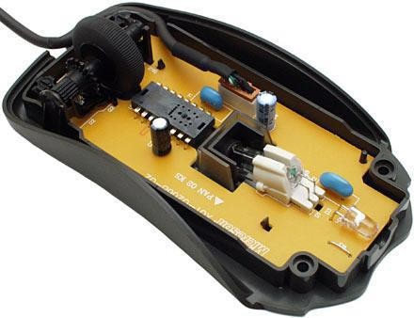
Figure 1.2- Optical Mouse, with top cover removed

The following table describes the advantages and disadvantages of the Optical and Laser Mouse
Advantages

- Allows better precision with lesser hand movements.
- Longer life-span.

Disadvantages

- Prone to button switches degradation.
- Does not function properly while on a polished surface.

Objective

The purpose of this project is to develop a Virtual Mouse application that targets a few aspects of significant development. For starters, this project aims to eliminate the needs of having a physical mouse while able to interact with the computer system through webcam by using various image processing techniques. Other than that, this project aims to develop a Virtual Mouse application that can be
operational on all kind of surfaces and environment.

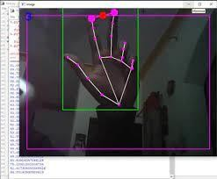
Figure 1.3- Hamd Gesture Mouse

The following describes the overall objectives of this project:

- To design to operate with the help of a webcam.

- The Virtual Mouse application will be operational with the help of a webcam, as the webcam are responsible to capture the images in real time.
- The application would not work if there are no webcam detected.

- To design a virtual input that can operate on all surface.

- The Virtual Mouse application will be operational on all surface and indoor environment, as long the users are facing the webcam while doing the motion gesture.
- To program the camera to continuously capturing the images, which the images will be analysed, by using various image processing techniques.
- As stated above, the Virtual Mouse application will be continuously capturing the images in real time, where the images will be undergo a series of process, this
includes HSV conversion, Binary Image conversion, salt and pepper noise filtering, and more.
- To convert hand gesture/motion into mouse input that will be set to a particular screen position.

The Virtual Mouse application will be programmed to detect the position of the defined colours where it will be set as the position of the mouse pointers. Furthermore, a combination of different colours may result in triggering different types of mouse events, such as the right/left clicks, scroll up/down, and more.

Mouse of a computer is a very useful object and helps in a huge way in letting us communicate with the computer. But the problem arises when the person using the mouse is a physically handicapped person. So while in some cases it can be difficult to use a mouse, in some other it might be almost impossible due to the extent of being

handicapped.

So to address this issue we have designed a system that will help in controlling the mouse with the help of a GRS. Another problem that will be addressed while making GRS is that usage of mouse is inconvenient while travelling and so a better system needs to be in place to help for the same and GRS while come to our rescue.

Scope

Virtual Mouse that will soon to be introduced to replace the physical computer
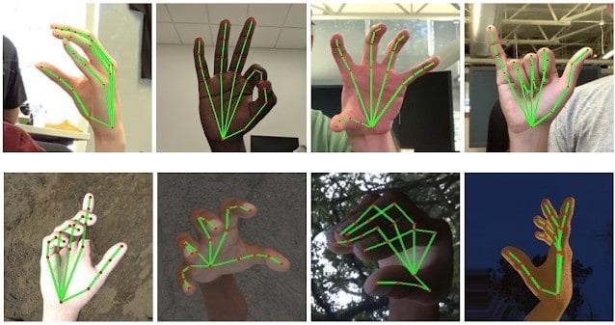
mouse to promote convenience while still able to accurately interact and control the computer system. To do that, the software requires to be fast enough to capture and process every image, in order to successfully track the user's gesture.

Figure 1.4- Hand Gesture Recognition

Therefore, this project will develop a software application with the aid of the latest software coding technique and the open-source computer vision library also known as the OpenCV.

The scope of the project is as below:

- Real time application.

- User friendly application.

- Removes the requirement of having a physical mouse.

The process of the application can be started when the user's gesture was captured in real time by the webcam, which the captured image will be processed for segmentation to identify which pixels values equals to the values of the defined colour. After the segmentation is completed, the overall image will be converted to Binary Image where the identified pixels will show as white, while the rest are black. The position of the white segment in the image will be recorded and set as the position of the mouse pointer, thus resulting in simulating the mouse pointer without using a physical computer mouse.

The software application is compatible with the Windows platform. The functionality of the software will be coded with Python programming language code with the integration of an external library that does the image processing known as the OpenCV.

The two most common methods for hand gesture recognition are vision-based, which employs image processing techniques with input from a camera, and hardware-based, which requires the user to wear a device. The suggested system is obviously a visionbased system that makes use of camera inputs and image processing algorithms.

Our objective is to offer more gestures so that users may complete more tasks quickly in the future. This proposal suggests a system that only makes use of the proper hand when making gestures. As a result, it will be feasible to use both hands for certain gestures in the future thanks to improvements made to the method that is

presently in use. The end user will save time and effort using this suggested approach, and people who are blind or disabled will be able to utilize computers more easily.

Impact, Significance and Contribution

The Virtual Mouse application is expected to replace the current methods of
utilizing a physical computer mouse where the mouse inputs and positions are done manually. This application offers a more effortless way to interact with the computer system, where every task can be done by gestures.
Furthermore, the Virtual Mouse application could assist the motor-impaired users where he/she could interact with the computer system by just showing the correct combination of colours to the webcam.

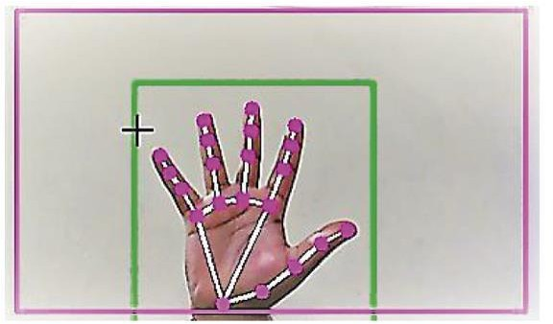

Figure 1.5- Virtual Mouse using Computer Vision

Project Requirements

Hardware

The following describes the hardware needed in order to execute and develop the Virtual Mouse application:

□ Computer Desktop or Laptop

The computer desktop or a laptop will be utilized to run the visual software in order to display what webcam had captured. A notebook which is a small, lightweight and inexpensive laptop computer is proposed to increase mobility.
System will be using

Processor : Core2Duo Main Memory : 4GB RAM Hard Disk : 320GB
Display : 14" Monitor

□ Webcam

Webcam is utilized for image processing, the webcam will continuously taking image in order for the program to process the image and find pixel position

Software

The following describes the software needed in-order to develop the Virtual Mouse application, Software will be using:

OS : Window 11 Ultimate 64-bit

Language : Python

Libraries Used : Open CV, Mediapipe and pyautogui

Chapter 2 : System Analysis

Literature Survey

To meet the increasing importance of human-computer interaction (HCI), several mice have been created, from the basic office mouse to an extreme gaming mouse. Because they aren't as ecologically friendly as they seem to be, these gadgets have several drawbacks. For example, you'll need a flat surface and a certain position to utilise the mouse's functions. As a result, part of this technology is useless when remotely communicating with computers because of connection length constraints. Multi-point Interactive Whiteboards may be created with the Wiimote. Wiimote controller, Microsoft.NET framework, Wiimote Connect, and Wiimote Whiteboard software are all required for this setup to operate. An IR pen and 1024 x 786-pixel beamer are also required. The Wiimote controller tracks the whiteboard’s infrared source, which sends data to the PC via Bluetooth.

Multi-touch teaching stations, an interactive whiteboard, and a stylus input conversion tool, are all part of the platform. Most people use the Wii-mote as a virtual marker based on an assessment of relevant research Hand gestures are not supported in the current setup, only a mouse and trackpad display control system. A hand gesture cannot be used to reach the monitor's display screen from a distance. Even though this is what it mainly seeks to do, the breadth is only limited to the virtual mouse region. In the present virtual mouse control system, the mouse cursor, left-click, right-click and drag are controlled by a hand recognition system.

Abolishing the practice of hand recognition will be the new standard in the future.
Even though a variety of hand recognition systems are available, only a few
movements are given for each hand-made shape, which leads to a great deal of
ambiguity and makes the "still hand" difficult to grasp. It's becoming more difficult to justify using a mouse in the modern world as technology advances. A sensor may be used to move the mouse cursor around the screen (or a built-in camera). The software's dwell delay feature is widely used when a mouse button is unavailable.
14

Clicking may also be accomplished with the aid of a well-placed switch. As modern technology of human computer interactions become important in our everyday lives, varieties of mouse with all kind of shapes and sizes were invented, from a casual office mouse to a hard-core gaming mouse. However, there are some limitations to
these hardware as they are not as environmentally friendly as it seems. For example, the physical mouse requires a flat surface to operate, not to mention that it requires a certain area to fully utilize the functions offered. Furthermore, some of this hardware are completely useless when it comes to interact with the computers

remotely due to the cable lengths limitations, rendering it inaccessible.

Mouse Simulation Using Two Coloured Tapes

Kamran Niyazi et al. (2012), mentioned that to solve the stated problem, ubiquitous computing method is required. Thus, colour tracking mouse simulation was proposed. The said system tracks two colour tapes on the user fingers by utilizing the computer vision technology. One of the tapes will be used for controlling the
movement of the cursor while the other will act as an agent to trigger the click events of the mouse.

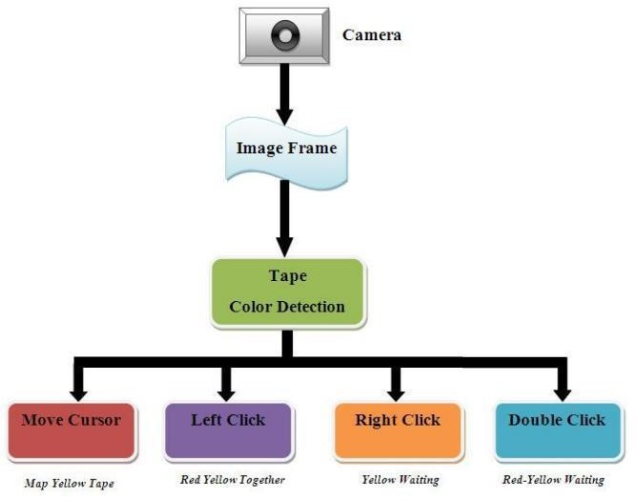
Figure 2.1- The system architecture of the mouse-simulation

To detect the colours, the system are first required to process the captured image by separating the hand pixels from the non-hand pixels, which can be done by background subtraction scheme that segments the hands movement information from the non-changing background scene. In order to implement this, the system requires to capture a pair of images to represent the static workplace from the camera view.
When subtraction process is complete, the system will undergo another process that separates the RGB pixels to calculate 20

the probability and differentiate the RGB values to determine which part are the skin and which are not. After the process is completed, it will start detecting the defined colour in the image, the image RGB pixels will be converted into HSV colour plane in order to eliminate the variation in shades of similar colour. The resulting image will be converted to Binary Image and will undergo a filtering process to reduce the noise within the image.

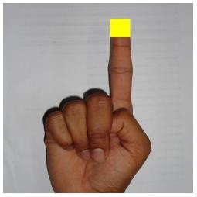
Figure 2.2- Yellow colour tape for cursor movement

Even though the proposed system solved most of the stated issues, but there are limited functions offered by the proposed system as it merely able to perform

common functions, such as: cursor movements, left/right click, and double clicks. While other functions, such as the middle click and mouse scroll were ignored.

Virtual Mouse Using a Webcam

Another colour detection method proposed by Kazim Sekeroglu (2010), the system requires three fingers with three colour pointers to simulate the click events. The proposed system are capable of detecting the pointers by referring the defined colour information, track the motion of the pointers, move the cursor according to the
position of the pointer, and simulate the single and double left or/and right click event of the mouse.

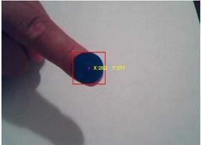
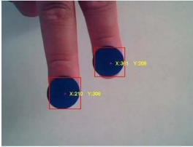

Figure 2.3- Input image using one and two pointers

To detect the colours, they have utilized the MATLAB's built in "imsubtract"
function, with the combination of the noise filtering by using median filter, which are effective in filtering out or at least reduce the "salt and pepper" noise. The captured
image will be converted to Binary Scale Image by using MATLAB's built in "im2bw" function to differentiate the possible values for each pixel. When the
conversion is done, the captured image will undergo another filtering process by using "bwareaopen" to remove the small areas in order to get an accurate number of the object detected in the image.

Portable Vision-Based Human Computer Interaction (HCI)

Another "Ubiquitous Computing" approach proposed by Chu-Feng Lien (2015), requires only finger-tips to control the mouse cursor and click events. The proposed system doesn't requires hand-gestures nor colour tracking in order to interact with the system, instead it utilize a feature name Motion History Images(MHI) , a method that used to identify movements with a row of images in time.

Even though the proposed system possess good accuracy in a well-controlled environment, it does has its own limitations. The proposed system are not capable to detect fast moving movements as the frame-rates are not able to keep up, thus
leading to increase of error rate. Furthermore, due to the mouse click events occurred when the finger hold on a certain positions, this may lead to user constant finger
movements to prevent false alarm, which may result inconvenience.

Conclusion

There are abundance of methods for computer interaction besides the traditional physical mouse interaction. With the evolutions of modern technology and
programming, so does the Human Computer Interaction (HCI) methods, as it allows unlimited ways to access the computers. This approach allows the developers to design specific/unique system that suit the needs of the users, from gesture

movement tracking to coloured tracking, it's no surprise that in near future, physical mouse will no longer be needed and be replaced by video cameras that tracks gestures.

Importance of Gesture recognition

Gesture recognition can be used to control devices or interfaces, such as a computer or a smartphone, through movements or actions, such as hand or body movements, facial expressions or even voice commands. Gesture recognition has a variety of uses, including:

      - Human-computer interaction: Gesture recognition can be used to control computers, smartphones, and other devices through gestures, such as swiping, tapping, and pinching.
      - Gaming: Gesture recognition can be used to control characters and objects in video games, making the gaming experience more immersive and interactive.
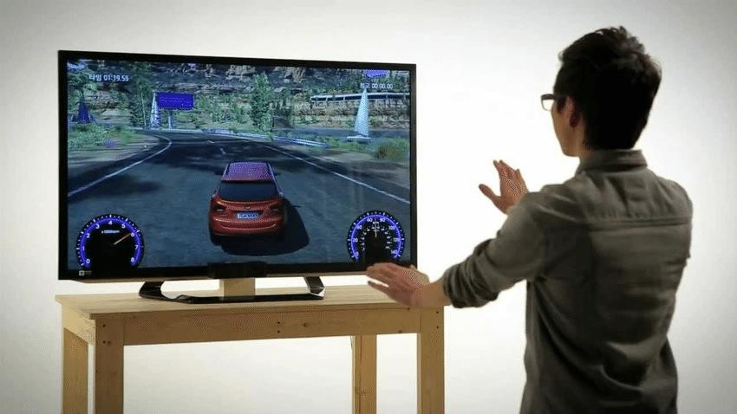

Figure 2.4- Used in Gaming

      - Virtual and augmented reality: Gesture recognition can be used to interact with virtual and augmented reality environments, allowing users to control and manipulate objects in those environments.

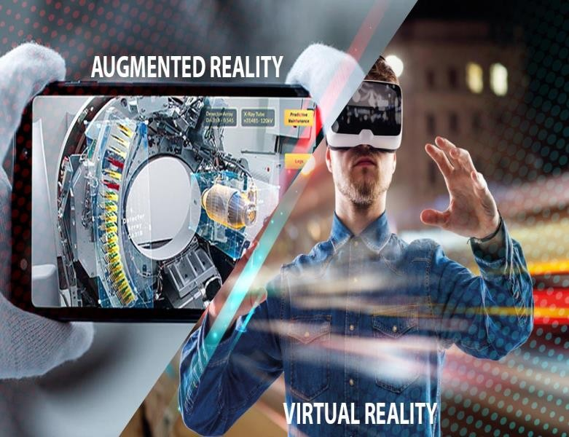

Figure 2.5- Used in Virtual augmented reality

      - Robotics: Gesture recognition can be used to control robots, allowing them to perform tasks based on the user’s gestures.
      - Sign language recognition: Gesture recognition can be used to recognize and translate sign language into spoken or written language, helping people who are deaf or hard of hearing communicate with others.
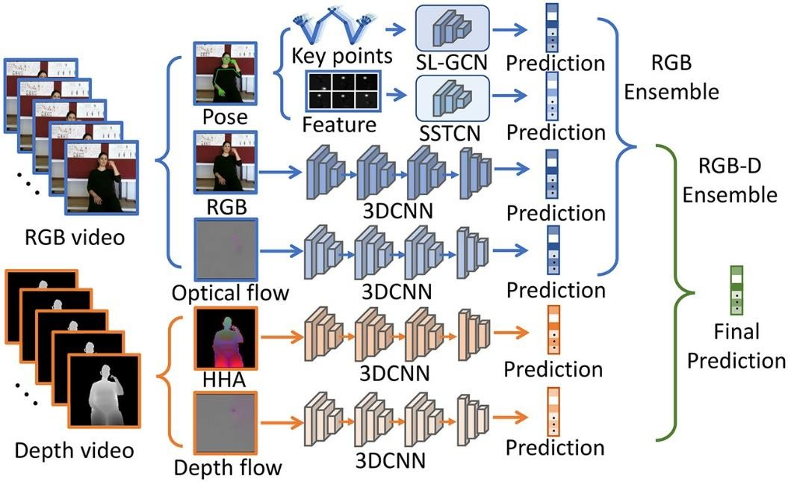

Figure 2.6- Used in Sign language recognition

      - Automotive: Gesture recognition can be used in cars to control various functions such as radio, AC, and navigation systems.
      - Healthcare: Gesture recognition can be used in rehabilitation of patients with physical disabilities.
      - Entertainment: Gesture recognition is used in TVs as a virtual remote.

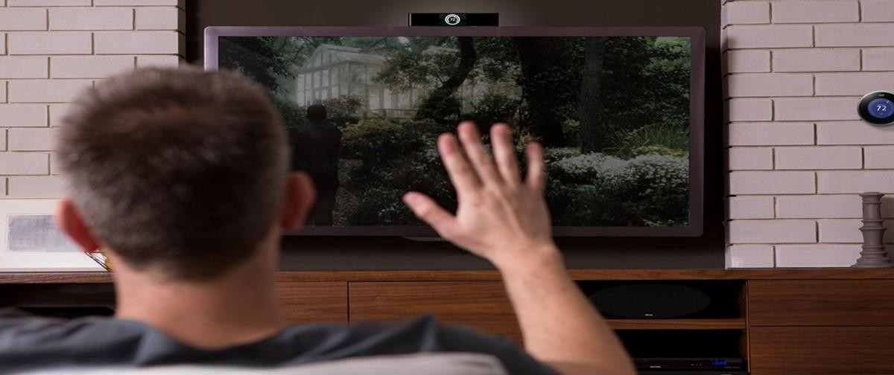

Figure 2.7- Used in virtual remote

Project Feasibility Study

The feasibility of the project is analyzed in this phase and business proposal is put forth with a very general plan for the project and some cost estimates. During system analysis the feasibility study of the proposed system is to be carried out. This is to ensure that the proposed system is not a burden to the company. For feasibility analysis, some understanding of the major requirements for the system is essential.
Three key considerations involved in the feasibility analysis are:

- Economical Feasibility

- Technical Feasibility

- Social Feasibility

Economical Feasibility :

The purpose of an economic feasibility study(EFS) is to demonstrate the net benefit of a proposed project for accepting or disbursing electronic funds/benefits, taking into consideration the benefits and costs to the agency, other state agencies, and the general public as a whole. This study is carried out to check the economic impact that the system will have on the organization. The amount of fund that the company can pour into the research and development of the system is limited. The expenditures must be justified. Thus, the developed system as well within the budget and this was achieved because most of the technologies used are freely available. Only the customized products had to be purchased.

Technical Feasibility :

A technical feasibility study assesses the details of how you intend to deliver a product or service to customers. Think materials, labor, transportation, where your business will be located, and the technology that will be necessary to bring all this together. This study is carried out to check the technical feasibility, that is, the technical

requirements of the system. Any system developed must not have a high demand on the available technical resources. This will lead to high demands available technical resources. This will lead to high demands being placed on the client. Apart from that, the modules like Open Computer Vision (OpenCV), Py Auto GUI, MediaPipe, Win32api are used.
The main objective of the virtual mouse system is to control the mouse curs or functions by using the hand gestures instead of using a physical mouse. The proposed system can be achieved by using a webcam or a built-in camera which detects the hand gestures and hand tip and processes these frame stoper form the particular mouse functions.

Operational Feasibility :

Digital Canvas is an extension of this system which is gaining popularity among artists, by which the artist could create 2D or 3D images using the Virtual Mouse technology using the hand as brush and a Virtual Reality kit or a monitor as display set. This technology can be used to help patients who don’t have control of their limbs. In case of computer graphics and gaming this technology has been applied in modern gaming consoles to create interactive games where a person’s motions are tracked and interpreted as commands.

Researchers around the world are now focused on to make our devices more interactive and trying to make the devices operational with minimal physical contact. In this research, we propose an interactive computer system which can operate without any physical keyboard and mouse. This system can be beneficial to everyone, especially to the paralyzed people who face difficulties to operate physical keyboard and mouse. We used computer vision so that user can type on virtual keyboard using a yellow-colored cap on his fingertip, and can also navigate to mouse controlling system. Once the user is in mouse controlling mode, user can perform all the mouse operations only by showing different number of fingers. We validated both module of our system by a 52 years old paralyzed person and achieved around 80% accuracy on average.

Methodology

In this work, they proposed a novel virtual mouse method using RGB-D images and f ingertip detection
This study consists of two methods for tracking the fingers, one is by using colored c aps and other is by hand gesture detection. This includes three main steps that are fing er detection using color identification, hand gesture tracking and implementation on o n-screen cursor. This paper presents a design for a fully operational hand-gesture cont rolled wearable mouse. It is a simple plug and play type device without the need for a special driver and other software support. In this paper a gesture recognition models i s designed which recognize hand gestures that is down, up, left, right and cross, based on the input signal from three-axis accelerometer. Integrated circuit is used.
The system will allow the user to navigate the computer cursor using their hand bearing color caps or tapes and left click and dragging will be performed using different hand gestures.
Steps in algorithm are as follows:
Step 1: Start

Step 2: Start the webcam video capture and initialize the system. Step 3: Frame capture with a webcam.
Step 4: Using Media Pipe and OpenCV, detect hands and hand tips and draw hand landmarks and a box around the hand.
Step 5: Draw a rectangle around the computer window area where we'll be using the mouse.
Step 6: Determine which finger is raised.

Step 6.1: The gesture is neutral if all five fingers are up, and the next step is ta

ken.

Step 6.2: The cursor moves to step 2 if both the middle and index fingers are r

aised.

Step 6.3: A double click is performed when both thumb and index fingers tou ch each
other, perform a left click and proceed to step 2.

Step 7: Press Esc to exit

      - The Camera Used in Virtual Mouse System- The proposed system uses web camer a for capturing images or video based on the frames. For capturing we are using CV l ibrary OpenCV which is belongs to python web camera will start capturing the video and OpenCV will create a object of video capture. To virtual system the frames are p assed from the captured web camera.

      - Capturing the Video and Processing:- The capturing of the frame was done with t he AI virtual mouse system until the program termination. Then the video captured h as to be processed to find the hands in the frame in each set. The processing takes pla ces is it converts the BRG images into RGB images, which can be performed with th e below

      - Rectangular Region for Moving through the Window The windows display is mar ked with the rectangular region for capturing the hand gesture to perform mouse acti on based on the gesture, when the hands are find under those rectangular area the det ection begins to detect the action based on that the mouse cursor functions will be per formed. The rectangular region is drawn for the purpose of capturing the hand gestur es through the web camera which are used for mouse cursor operations. Mouse Funct ions Depending on the Hand Gestures and Hand Tip Detection Using Computer Visi on:

- For the Mouse Cursor Moving around the Computer Window.

- To Perform Left Button Click operation

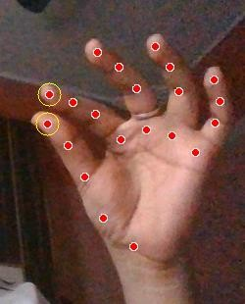

Figure 2.8- Mouse Operation-Left Click

- For No Action / neutral gesture to be Performed on the Screen

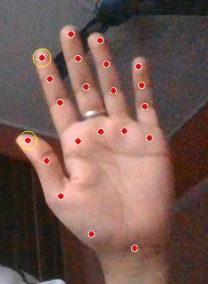

Figure 2.9- Neutral Gesture

Chapter 3 : System Design

3.1 Use Case Diagram
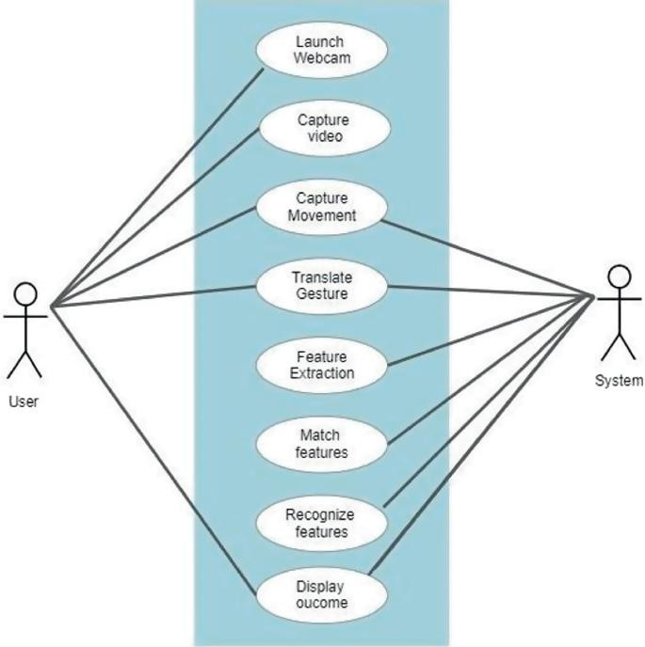

Figure 3.1- Use case Diagram
28

3.1 Data Flow Diagrams

3.1.1 Context-Level (Level 0) DFD

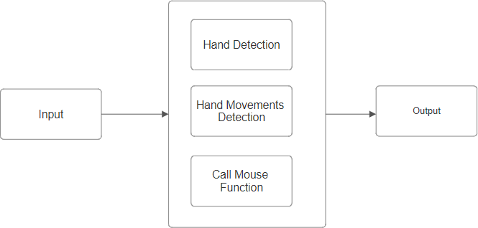

Figure 3.2- DFD 0 level Diagram

Level 1 DFD
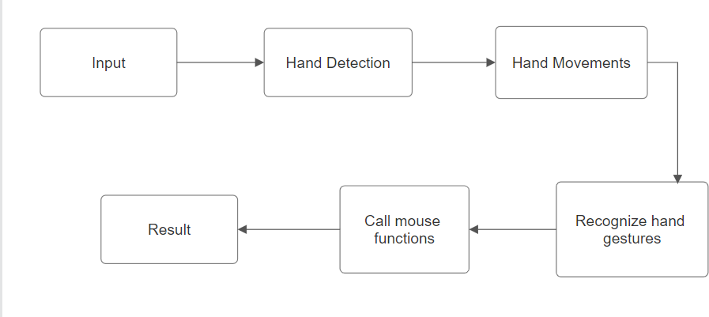
Figure 3.3- DFD 1 level Diagram

Level 2 DFD

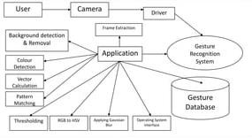

Figure 3.4- DFD 2 level Diagram

Flowchart

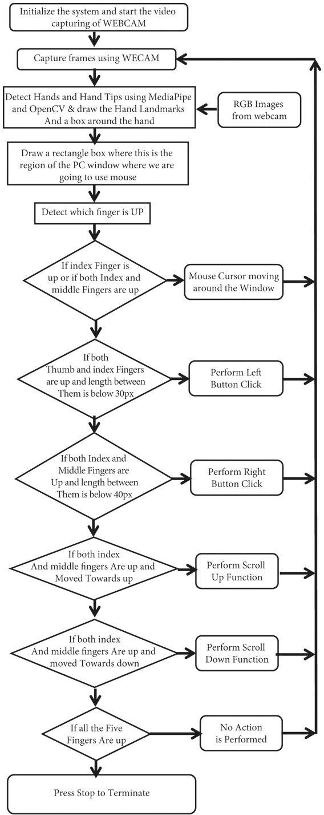

Figure 3.5- Flowchart

Block Diagram

Figure 3.6- Block Diagram

  - PYTHON

Chapter 4 : Software Tools

The coding technique on developing the Virtual Mouse application will be the Python with the aid of the integrated development environment (IDE) that are used for developing computer programs, known as the Microsoft Visual Studio. Python is a high level general purpose programming language Its design philosophy emphasises code readability with
the use of significant indentation Python is dynamically typed and garbage connected It supports multiple programming particles including structured, object oriented, and functional programming.



Figure 4.1- Python

For the purpose of hand and finger detection we are using the one of the effective open source library mediapipe, it is one type of the framework based on the cross platform features which was developed by google and Opencv to perform some CV related tasks. This algorithm uses machine learning related concepts for detecting the hand gesture and to track their movements. Algorithms used to track Hand Gestures

MEDIAPIPE

Google created the open-source MediaPipe framework to enable the development of cross-platform, real-time computer vision applications. For processing and analyzing
33

video and audio streams, it offers a number of pre-made tools and components, such as object detection, pose estimation, hand tracking, facial recognition, and more.
Mediapipe uses Machine Learning (ML) to mark 21 3D landmarks of a hand just from a single frame. MediaPipe Hands uses a number of models which are available in an ML pipeline.

A Hand Landmark Model operates on the cropped image region and a Palm Detection Model operates on the whole image and returns an oriented hand bounding box used for the hand detection process respectively.

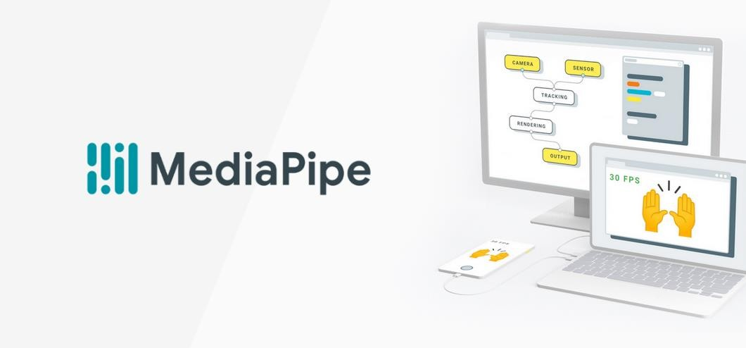

Figure 4.2- Mediapipe

The pipeline created can run in various platforms allowing scalability in mobile and desktops.
For computer vision and ML tasks, MediaPipe is a comprehensive library that offers a many of features.

Features
Here are a few of the library's main attributes and features: .

      - Video and Audio Processing: MediaPipe provides tools for processing and analyzing video and audio streams in real-time. This includes functionalities such as video decoding, filtering, segmentation, and synchronization.

      - Facial Recognition: MediaPipe can detect and track facial landmarks, including eyes, nose, mouth, and eyebrows, in real-time. This functionality is useful for applications such as facial recognition, emotion detection, and augmented reality.

      - Hand Tracking: MediaPipe can track hand movements in real-time, allowing for hand gesture recognition and interaction with virtual objects.

      - Object Detection: MediaPipe can detect and track objects in real-time using machine
learning models. This functionality is useful for applications such as augmented reality, robotics, and surveillance.

      - Pose Estimation: MediaPipe can estimate the poses of human bodies in real-time,
allowing for applications such as fitness tracking, sports analysis, and augmented reality or a variety of tasks, such as object

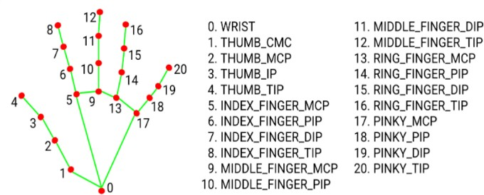

Figure 4.3- Hand Coordinates or Landmarks

detection, position estimation, facial recognition, and more, MediaPipe offers tools for
training and deploying machine learning models. All in all, MediaPipe is a potent tool kit that gives programmers the ability to easily create sophisticated real-time computer vision and ML applications.

OPENCV

A computer vision and ML software library called OpenCV is available for free download. Its objective is to aid programmers in the development of computer vision applications. Filtering, feature identification, object recognition, tracking, and other processing operations for images and videos are all available through OpenCV.

Python, Java, and MATLAB are just a few of the numerous programming languages that it has bindings for. It is written in C++.Robotics, self-driving cars, AR, medical image analysis, and other fields are just a few of the fields where OpenCV can be employed. A wide range of algorithms and tools are included in the library, making it simple for programmers to build sophisticated computer vision applications.

The steps listed below can be used to broadly classify OpenCV's operation:



Figure 4.4- Open CV

    - Loading and Preprocessing the Image/Video: OpenCV can load images or videos from a variety of sources such as files, cameras, or network streams. Once the image or video is loaded, it can be preprocessed by applying filters or transforming the image to a different color space, such as converting a color image to grayscale.

    - Feature Detection and Description: OpenCV can detect and extract features from an
image or video, such as edges, corners, and blobs. These features can be used to identify objects or track their motion over time. OpenCV also provides algorithms for describing these features, which can be used to match them across multiple frames or images.

    - Object Detection and Recognition: OpenCV can be used to detect and recognize objects in an image or video. This can be done using a variety of techniques, such as template
matching, Haar cascades, or deep learning-based methods.

    - Tracking: OpenCV can track objects in a video stream by estimating their position and motion over time. This can be done using a variety of algorithms, such as optical flow, mean-shift, or Kalman filtering . Image and Video Output: Finally, OpenCV can be used to display or save the processed images or videos. This can be done by showing the
images in a window, writing the video frames to a file, or streaming the video over a network.

In general, OpenCV offers a large variety of tools and techniques for working with image and video data, making it a potent library for computer vision applications.

PYAUTOGUI

Python pyautogui library is an automation library that allows mouse and keyboard control.
Or we can say that it facilitates us to automate the movement of the mouse and keyboard to establish the interaction with the other application using the Python script. It provides many features, and a few are given below.
      - o We can move the mouse and click in the other applications' window.

      - o We can send the keystrokes to the other applications. For example - filling out the form, typing the search query to browser, etc.
      - o We can also take snapshots and give an image.

      - o It allows us to locate a window of the application, and move, maximize, minimize, resizes, or close it.
      - o Display alert and message boxes.



Figure 4.5- Pyautogui

The x, y coordinates used by PyAutoGUI has the 0, 0 origin coordinates in the top left corner of the screen. The x coordinates increase going to the right (just as in mathematics) but the y coordinates increase going down (the opposite of mathematics). On a screen that is 1920 x 1080 pixels in size, coordinates 0, 0 are for the top left while 1919, 1079 is for
the bottom right.
Currently, PyAutoGUI only works on the primary monitor. PyAutoGUI isn't reliable for the screen of a second monitor (the mouse functions may or may not work on multi-
monitor setups depending on your operating system and version).
All keyboard presses done by PyAutoGUI are sent to the window that currently has focus, as if you had pressed the physical keyboard key.

TKINTER

Python has a lot of GUI frameworks, but Tkinter is the only framework that’s built into the Python standard library. Tkinter has several strengths. It’s cross-platform, so the same code works on Windows, macOS, and Linux. Visual elements are rendered using
native operating system elements, so applications built with Tkinter look like they belong on the platform where they’re run.
Although Tkinter is considered the de facto Python GUI framework, it’s not without criticism. One notable criticism is that GUIs built with Tkinter look outdated. If you want a shiny, modern interface, then Tkinter may not be what you’re looking for.

However, Tkinter is lightweight and relatively painless to use compared to other
frameworks. This makes it a compelling choice for building GUI applications in Python, especially for applications where a modern sheen is unnecessary, and the top priority is to quickly build something that’s functional and cross-platform.



Figure 4.6- TKinter

Chapter 5 : Implementation and Testing

Testing

Testing plays a critical role for quality assurance and for ensuring the reliability of the software. Its basic function is to detect the errors. After the coding phase, testing is done to test the proper working of the new system. Testing is the process of executing a program with the intention of finding errors. It is a complete verification to determine whether the objectives are met and the user requirements are satisfied. The testing phase involves testing of a system using various test data.
Preparation of the test data plays a vital role in the system testing. After preparing the test data, the system under study is testing using those test data. Errors were found and corrected by using the following testing steps and corrections are recorded for future references. Thus, a series of testing is performed on the system before it is ready for coding. Since code is the only product that can be executed frequently whose actual behavior can be observed, this phase is so important for the successful implementation of the software product. Thus, the goal of testing is to uncover the requirements, design and coding errors in the program.


Figure 5.1- Bug Detection

Unit Testing

The first step in the testing is the unit testing. Unit test is normally considered as an adjunct to the coding step. After the coding has been developed, received and verified for correct syntax, unit testing begins. The standalone modules were tested individually for their correct functionality, with the corresponding data. This ensures the reliability of the
40

modules when integrated. Each and every module is tested independently with sample data and it was found that all modules are properly functioning. Using the unit test plans, prepared in the design phase of the system as a guide, important control paths are tested to uncover errors within the boundary of the modules. Boundary conditions were checked, all independent paths were exercised to ensure that all statements in the module are checked at least once and all error handling paths were tested. Each unit was thoroughly tested to check if it might fall in any possible situation. This testing was carried out during the programming itself. At the end of this testing phase, each unit was found to be working satisfactory, as regard to the expected output from the module.

Integration Testing

The second step in the testing process is the Integration testing. Integration testingis the systematic technique for constructing the program structure while conducting tests to uncover errors associated with interfacing. All the modules when unit testing willwork properly but after interfacing the data can be lost across an interface, one module can have an inadvertent, adverse effect on other, sub functions when combined maynot produce the desired major function, global data structures can cause problems, etc.
Integration testing was performed by integrating all the individual modules and the activities of the user such as loading layers, retrieving information from any functions applying themes based on the records present in the database etc. and is found that it works good to the examination of the end users. Hence, the objective of integration testing is to take unit tested modules and build a final program structure.

All the modules developed are independent. Even the whole process of approval for all. Each module is integrated well with other modules. And all the interfaces are tested successfully.

Functional Testing

This test involves testing the system under typical operating conditions with sample input values. Functional testing was performed on the system by giving existing industryid or plot number and a null or string as the input for any field in which case the user should be redirected to the same state with the appropriate message, rather thanproceeding and crashing in the system.
Functional testing was performed on the system by raising the demand with an eye to

check all the validations. The total processing of the system is satisfactory with the following results.

- All the validations are clearly notified to the user regarding jobseekers reg, newclient reg, job order, job providers, and job search preparation etc.

- Almost all the functional errors, data storage errors and all types of logical errorsare tested successfully.

Acceptance Testing

User acceptance test of a system is the factor for the success of the system. The system under consideration was listed for user acceptance by keeping constant touch with the perspective user of the system at the time of design, development and making changes whenever required for unit testing.
The requirements of the customer are gathered at regular intervals at the developingsite itself. The problems that are to be visualized through this tool are been gathered by the customer and are reported.

Implementation and challenges

Many previous studies on hand-gesture recognition have been conducted using colored gloves or markers. Despite remarkable successes, recognition remains challenging, due to the complexity of using gloves, markers, or variable glove sizes for users. Consequently, many recent efforts have focused on camera-based interfaces.
In this project, there are several existing problems that may hinder the results of colour recognitions. One of the problems is the environmental factor during the recognition phase takes place. The recognition process are highly sensitive on the intensity of brightness, as immense brightness or darkness may cause the targeted colours to be undetected within the captured frames.

Besides that, distance is also the one of the problem that may affect the colour recognition results, as the current detection region can support up to 25cm radius, any display of colours exceed the mentioned distance will be considered as a noise and be filtered off.

Furthermore, the performance of the program are highly dependent on the users' hardware, as processor speed and/or resolutions taken from the webcam could have an effect on performance load. Therefore, the slower the processing speed and/or the higher the resolutions, the longer time are required to process a single frame.
In recent years, traditional camera-based approaches that detect the area of the hand and recognize hand gestures have been developed.

These approaches had obvious detection difficulty when the light levels were changed or a complex background was used and required a fixed distance from the camera to the users.

The first challenge was to correctly detect the hand with a webcam. We had to learn about the skin detection techniques and image processing techniques like Background
Subtraction, Image Smoothening, Noise Removal and Reduction.
Throughout the development of the application, there are several implementation issues occurred. The following describes the issues and challenges that will likely to be encountered throughout the development phase:

The interruptions of salt and pepper noises within the captured frames.

Salt and pepper noises occurred when the captured frame contains required HSV values
that are too small, but still underwent a series of process even though it’s not large enough to be considered an input. To overcome this issue, the unwanted HSV pixels within the frame must first be filtered off, this includes the area of the pixels that are too large and small. With this method, the likelihood of interruptions of similar pixels will reduce
greatly.

Performance degradation due to high process load for low-tier system.

Since the application is required to undergo several of process to filter, process and execute the mouse functions in real time, the application can be CPU intensive for most of the low-tier system. If the size of the captured frames is too large, the time-taken for the application to process the entire frame are increase drastically. Therefore, to overcome
this issue, the application is required to process only the essential part of the frames, and reduces the redundant filtering process that could potentially slow the application down.

The difficulties of calibrating the brightness and the contrast of the frames to get the required HSV values.

The intensity of brightness and contrast matters greatly when it comes to acquiring the required colour pixels. In order for the application to execute the entire mouse functions provided, all of the required HSV values to execute the specific mouse functions must be satisfied, meaning that the overall HSV values must be satisfied with the brightness and contrast as well. However, the calibration can be somewhat tedious as certain intensity could only satisfy part of the required HSV values, unless the original HSV values were modified to prove otherwise. To overcome this issue, the application must first start up with a calibration phase, which allows the users to choose their desired colour pixels before directing them to the main phase

  - Snapshots

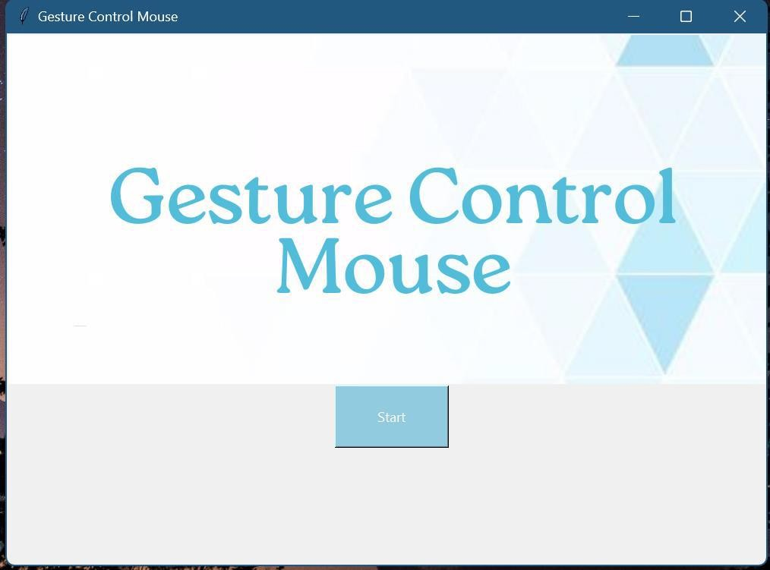
Figure 5.2- User interface

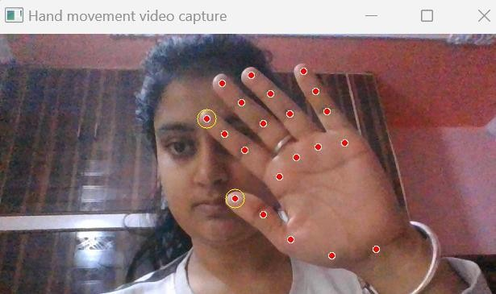

Figure 5.3- Hand Detection

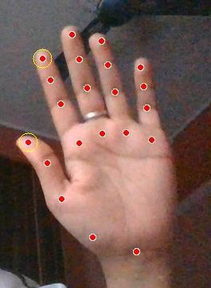
Figure 5.4.- Landmark Marking

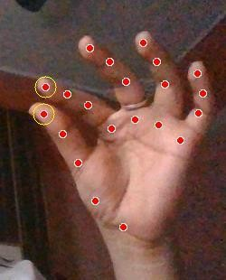
Figure 5.5- Hand Movement Detection

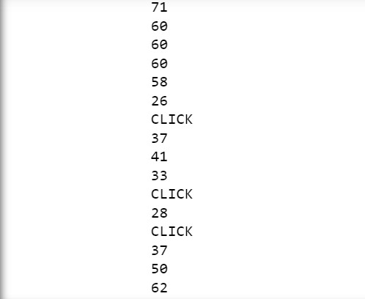
Figure 5.6- Distance Measurement

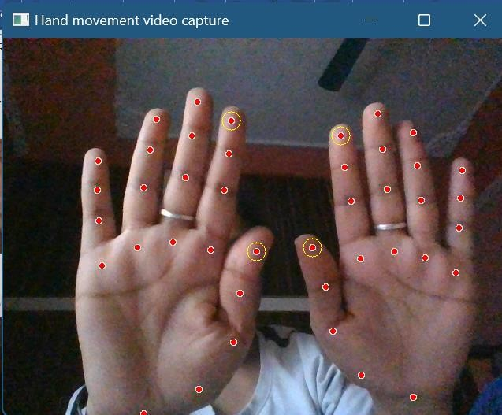
Figure 5.7- Multiple Hand Detection

Test Cases and Results

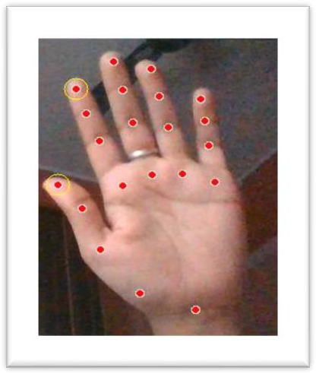 | Result :  Hand is recognized in light. And mouse works accurately.
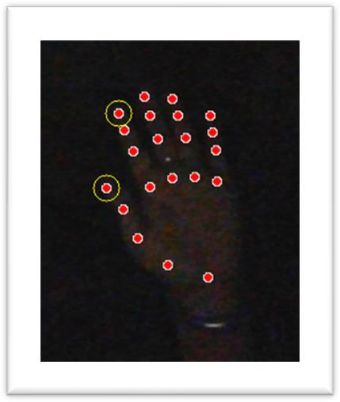 |  | Result :  Hand is recognized in light. And mouse works accurately.
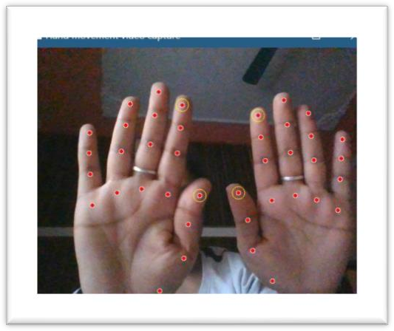 |  | Result :  Hand is recognized in light. And mouse doesn’t work fine. It jumps between both hands for reading the control of mouse.

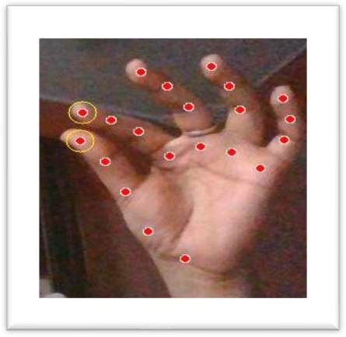 | Result :  Hand is recognized in light. And mouse works accurately, and performes right click on touching fore finger and thumb.
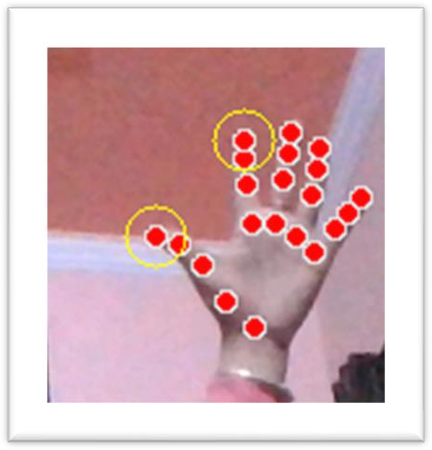 | Result :  Hand is recognized from far away distance to, upto 1-2 meters. And mouse works fine. But it reads right click as the distance between fore finger and thumb automatically decreases with respect to distance.

Figure 5.8- Test Case and results

51

Chapter 6 : Conclusion and Future Scope

Conclusion

In conclusion, it’s no surprised that the physical mouse will be replaced by a virtual non- physical mouse in the Human-Computer Interactions (HCI), where every mouse
movement can be executed with a swift of your fingers everywhere and anytime without any environmental restrictions. This project had developed a colour recognition program with the purpose of replacing the generic physical mouse without sacrificing the accuracy and efficiency, it is able to recognize colour movements, combinations, and
translate them into actual mouse functions. Due to accuracy and efficiency plays an important role in making the program as useful as an actual physical mouse, a few techniques had to be implemented.

First and foremost, the coordinates of the colours that oversee handling the cursor movements are averaged based on a collection of coordinates, the purpose of this technique is to reduce and stabilize the sensitivity of cursor movements, as slight
movement might lead to unwanted cursor movements. Other than that, several colour combinations were implemented with the addition of distance calculations between two colours within the combination, as different distance triggers different mouse functions. The purpose of this implementation is to promote convenience in controlling the program without much of a hassle. Therefore, actual mouse functions can be triggered accurately with minimum trial and errors.

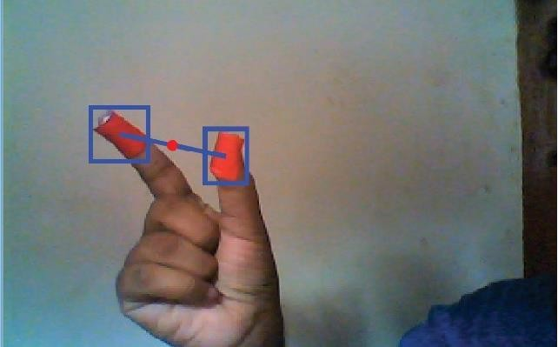
Figure 6.1- Distance detection

Furthermore, to promote efficient and flexible tracking of colours, calibrations phase was implemented, this allows the users to choose their choices of colours on different mouse functions, as long the selected colours doesn't fall within the same/similar RGB values (e.g. blue and sky-blue). Other than that, adaptive calibrations were also
implemented as well, it is basically allows the program to save different set of HSV values from different angles where it will be used during the recognition phase.

In Overall, the modern technologies have come a long way in making the society life better in terms of productivity and lifestyle, not the other way around. Therefore, societies must not mingle on the past technologies while reluctant on accepting changes of the newer one. Instead, it is advisable that they should embrace changes to have a more efficient, and productive lifestyle.

- Data storage and retrieval will become faster and easier to maintain because data is stored in a systematic manner and in a single database.

- Decision making process would be greatly enhanced because of faster processing of information since data collection from information available on computer takes much less time then manualsystem.

- Allocating of sample results becomes much faster because at a time the user can see the records of last years.

- Easier and faster data transfer through latest technology associated with the computer and communication.

- Through these features it will increase the efficiency, accuracy and transparency .

Future Work

There are several features and improvements needed in order for the program to be more user friendly, accurate, and flexible in various environments. The following describes
the improvements and the features required:

- Smart Recognition Algorithm

Due to the current recognition process are limited within 25cm radius, an adaptive zoom-in/out functions are required to improve the covered distance, where it can automatically adjust the focus rate based on the distance between the users and the webcam.

- Better Performance

The response time are heavily relied on the hardware of the machine, this includes the processing speed of the processor, the size of the available RAM, and the available features of webcam. Therefore, the program may have better performance when it's running on a decent machine with a webcam that performs better in different types of lightings.

Applications

- Amidst the COVID-19 situation, it is not safe to use the devices by touching them because it may result in a possible situation of spread of the virus by touching the devices, so the proposed AI virtual mouse can be used to control the PC mouse functions without using the physical mouse
- The system can be used to control robots and automation systems without the usage of devices
- AI virtual mouse can be used to play virtual reality- and augmented reality-based games without the wireless or wired mouse devices
- Persons with problems in their hands can use this system to control the mouse functions in the computer.

Advantages

- The system is easy to install.
- It can be used as easy mouse control for users.
- It is not an electronic based system so one can easily make use of laptops to install this system.
- It is cost-effective.
- It maximizes accuracy and reduces energy usage.

Disadvantages

- It requires a lot of memory.
- The alarm it has limited accuracy.

References
56

Books

[1]. Quam, D.L., et.al. (1990). Gesture Recognition with a Dataglove. In IEEE conference on Aerospace and Electronics (pp. 755-760).

  - Guoli Wang., et.al. (2015). Optical Mouse Sensor-Based Laser Spot Tracking for HCI input, Proceedings of the Chinese Intelligent Systems Conference (pp. 329-340).

  - Baldauf, M., and Frohlich, p. (2013). Supporting Hand Gesture Manipulation of Projected Content with mobile phones. In the European conference on computer vision (pp. 381-390).

  - Roshnee Matlani., Roshan Dadlani., Sharv Dumbre., Shruti Mishra., & Abha Tewari. (2021). Virtual Mouse Hand Gestures. In the International Conference on Technology Advancements and innovations (pp. 340-345).

  - Mayur, Yeshi., Pradeep, Kale., Bhushan, Yeshi., & Vinod Sonawane. (2016). Hand Gesture Recognition for Human-Computer Interaction. In the international journal of scientific development and research (pp. 9-13).

Websites

https://www.slidshare.net/ https://www.wikipedia.org/ https://medium.com/ www.youtube.com www.github.com

